**AI Language Lab – Language Service**

Note: This Low Code lab requires access to:

* the AI Language Service in Azure AI Foundry
* Access to provision Logic Apps and resources in Azure
* Azure OpenAI *(bonus/advanced only for Agent creation)*

**Overview**

In this lab you will interact with the Azure AI language cognitive service API using the Logic App low code workflow designer. You will create 2 low code Logic Apps  
(1) for PII removal  
(2) for Language detection and translation  
  
For advanced/bonus content you can use these Logic Apps to create AI agents.

**Create an Azure AI Foundry Project (if you did not create one for the demonstrations) and access Language API Key**

1. Login to Azure AI Foundry (<https://ai.azure.com/>).
2. Click **+Create new** and then Azure AI Foundry resource  
   *(Note the “AI Foundry Setup - for Customer.docx” document to ensure Foundry Hub is correctly setup)*A screenshot of a computer

   AI-generated content may be incorrect.
3. Give your project a name (lab participants may like to name the project *“<<Name>>-AI-Lang-Project”*)  
   A screenshot of a project

   AI-generated content may be incorrect.
4. Once the project is created and opens, on the Overview page make note of the Azure AI Services endpoint and API Key:  
   A screenshot of a computer

   AI-generated content may be incorrect.
5. Store these values:  
   APIKey  
   Target *(Endpoint)*

You will use these details to connect to the Language Service.

**Create a PII redaction Logic App**

In this section you will create a Logic App flow that receives input of text and outputs the text with the PII information redacted. This Logic App will create an endpoint that can be called from other applications.

1. In [portal.azure.com](https://portal.azure.com/) navigate to **+ Create a resource** and search for *Logic App* then click **Create.** Under plan choose Multi-tenant under Consumption and then click **Select.**
2. Select the same Resource Group as your AI Foundry project and follow the prompts to create a Logic App resource:  
   A screenshot of a computer

   AI-generated content may be incorrect.
3. Once provisioned select **Go to Resource** in the Azure Portal to open up the new Logic App. Expand Development tools and open Logic App Designer. Select **Add a trigger.**A screenshot of a computer

   AI-generated content may be incorrect.
4. Search triggers for “When a HTTP request is received” and select it
5. Under Request Body JSON Schema add the text below  
   {

  "type": "object",

  "properties": {

    "HTTP_URI": {

      "description": "URI for HTTP Request",

      "type": "string"

    },

    "HTTP_request_content": {

      "description": "Content or Body of the HTTP Request",

      "type": "string"

    }

  }

}

1. In the description field add the following:  
   *When a request is received review the message for PII data and redact it with a ******.*  
   A screenshot of a computer

   AI-generated content may be incorrect.
2. Click the plus sign to add an action then **select Add an action**  
   A white box with blue text and black text

   AI-generated content may be incorrect.
3. Search for *Parse JSON* and select the option under Data operationsA screenshot of a computer

   AI-generated content may be incorrect.
4. Under Content select the Dynamic content lightning bolt  
   A screenshot of a computer

   AI-generated content may be incorrect.  
   and under When a HTTP request is received select Body  
   A screenshot of a search box

   AI-generated content may be incorrect.
5. Under the Schema box paste in:  
   {

    "type": "object",

    "properties": {

        "description": {

            "type": "string"

        }

    }

}

1. The final screen should look like the screenshot below:  
   A screenshot of a computer

   AI-generated content may be incorrect.
2. Select Save on the canvas
3. Click the plus sign to add an action then **select Add an action**A white box with blue text and black text

   AI-generated content may be incorrect.
4. Search for *Azure Language* and then click **See more**  
   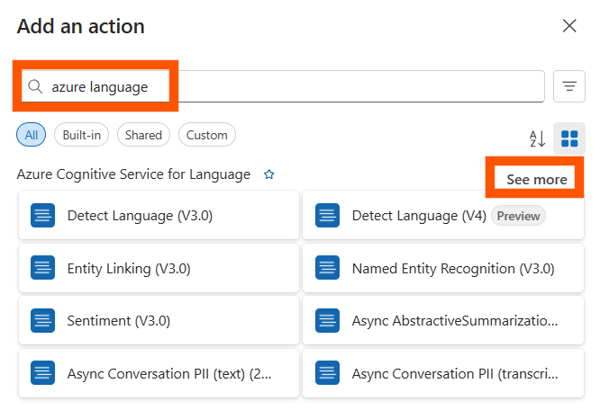
5. Select Detect Personal Information (V3.1)  
   A close-up of a white background

   AI-generated content may be incorrect.
6. Select Authentication Type as Api Key and then add the API Key you saved into the Account Key box and the Endpoint (Target) into the Site URL field then click **Create New**  
   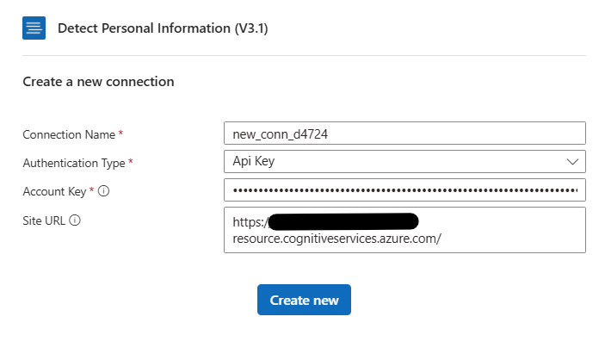
7. Select the Detect Personal Information action and under Parameters search for the Documents heading. Select **+ Add new item**.   
   A screenshot of a computer

   AI-generated content may be incorrect.  
   Insert the following values:   
   *Id-1 = 1   
   Text-1 = Insert expression (fx)*  
   *A screenshot of a computer

   AI-generated content may be incorrect.*
8. In the pop up expression window select the description component of the JSON output by pasting in:  
     
   body('Parse_JSON')['description']  
     
   Then click **Add**A screenshot of a computer

   AI-generated content may be incorrect.
9. Click the plus sign to add the final action for the flow then **select Add an action**  
   A white box with blue text and black text

   AI-generated content may be incorrect.
10. Search for *Response* and then select the option under Request  
    A white rectangular object with black text

    AI-generated content may be incorrect.
11. Fill in the parameters for the Response leaving Status Code as 200 (indicating that the request has succeeded).
12. In the Body select the expression using the *fx* icon that appears on click inside Body field   
    A computer screen shot of a computer screen

    AI-generated content may be incorrect.  
    and paste in the following expression:  
      
    body('Detect_Personal_Information_(V3.1)')['documents'][0]['redactedText']  
      
    A screenshot of a computer

    AI-generated content may be incorrect.
13. Save your Logic App using the Save button at the top of the page
14. Select the arrow next to Run then Run with payload  
    A screenshot of a computer

    AI-generated content may be incorrect.
15. In the Body of the of the Run with payload pane paste the following then click Run:  
    {

   "description" : "My phone number is (04) 12 345 678"

}

1. Confirm that the output displays the redacted phone number:  
   A screenshot of a computer

   AI-generated content may be incorrect.
2. Once verified, close the Logic App

**Create a Translation Logic App**

In this section you will create a Logic App flow that receives input of text, detects the language of the text and then outputs the text in English. This Logic App will create an endpoint that can be called from other applications.

1. In [portal.azure.com](https://portal.azure.com/) search for *Logic Apps* in the top blue bar and select the option that appears:  
   **A screenshot of a computer

   AI-generated content may be incorrect.**
2. Click **+ Add** to add a new Logic App and choose Multi-tenant under Consumption, then click **Select**
3. Ensure you are selecting the same region, and resource group as your Foundry project.   
   Name your Logic App   
   *EnglishTranslation*
4. Review and Create the Logic App, then select **Go to resource** once it has been provisioned
5. Under development tools select **Logic app designer** and thenselect **Add a trigger.**A screenshot of a computer

   AI-generated content may be incorrect.
6. Search triggers for “When a HTTP request is received” and select it
7. Under Request Body JSON Schema add the text below  
   {

  "type": "object",

  "properties": {

    "HTTP_URI": {

      "description": "URI for HTTP Request",

      "type": "string"

    },

    "HTTP_request_content": {

      "description": "Content or Body of the HTTP Request",

      "type": "string"

    }

  }

}

1. In the description field add the following:  
   *Receives an HTTP request in the description field of some text. Then translates that text to English.*  
   A close-up of a box

   AI-generated content may be incorrect.
2. Select Save
3. Click the plus sign to add an action then **select Add an action**  
   A white box with blue text and black text

   AI-generated content may be incorrect.
4. Search for *Parse JSON* and select the option under Data operationsA screenshot of a computer

   AI-generated content may be incorrect.
5. Under Content select the Dynamic content lightning bolt  
   A screenshot of a computer

   AI-generated content may be incorrect.  
   and under When a HTTP request is received select Body  
   A screenshot of a search box

   AI-generated content may be incorrect.
6. Under the Schema box paste in:  
   {

    "type": "object",

    "properties": {

        "description": {

            "type": "string"

        }

    }

}

1. The final screen should look like the screenshot below:  
   A screenshot of a computer

   AI-generated content may be incorrect.
2. Select Save on the canvas
3. Click the plus sign to add an action then **select Add an action**A white box with blue text and black text

   AI-generated content may be incorrect.
4. Search for *Azure Language* and then click **See more**
5. Search for *Microsoft Translator V3* and then click **See more**
6. Select Translate Text. Create the connection to using the same API Key and Resource name (do not use the full Endpoint only the name of the resource) from Foundry. Eg  
   A screenshot of a computer

   AI-generated content may be incorrect.
7. Under Parameters set:  
   **Source Language** Auto-detect  
   **Target Language** English  
   **Body Text-1** *Choose expression fx*  
     
   A close-up of a computer screen

   AI-generated content may be incorrect.  
     
   In the expression field paste in:  
     
   body('Parse_JSON')['description']  
     
   Then click Add.   
     
   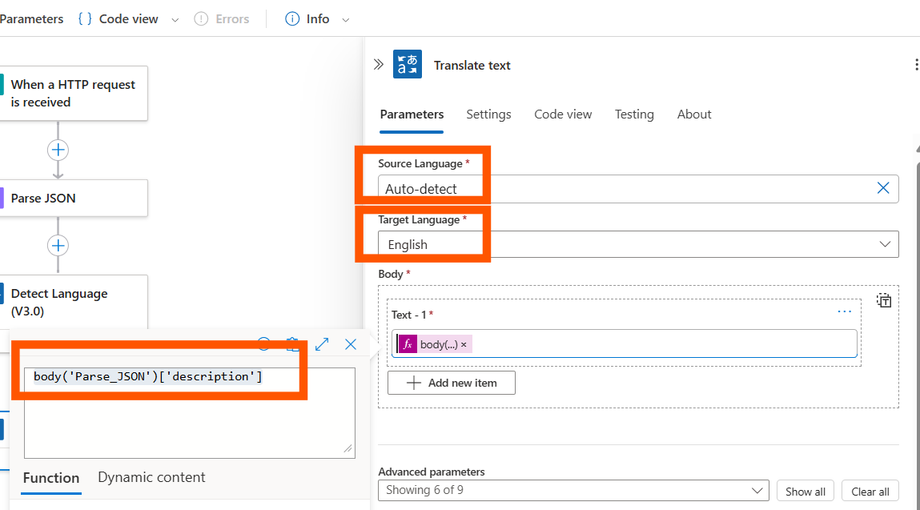  
   A screenshot of a computer

   AI-generated content may be incorrect.
8. Click on Save
9. Click the plus sign to add the final action for the flow then **select Add an action**  
   A white box with blue text and black text

   AI-generated content may be incorrect.
10. Search for *Response* and then select the option under Request  
    A white rectangular object with black text

    AI-generated content may be incorrect.
11. Fill in the parameters for the Response leaving Status Code as 200 (indicating that the request has succeeded).
12. In the Body select the expression using the *fx* icon that appears on click inside Body field   
    A computer screen shot of a computer screen

    AI-generated content may be incorrect.  
    and paste in the following expression:  
      
    body('Translate_text')[0]['TranslatedText']

1. Save your Logic App using the Save button at the top of the page
2. Select the arrow next to Run then Run with payload  
   A screenshot of a computer

   AI-generated content may be incorrect.
3. In the Body of the of the *Run with payload* pane paste the following then click Run:  
   {

   "description" : "Mi número de teléfono es (04) 12 345 678"

}  
{

   "HTTP_request_content" : "Mi número de teléfono es (04) 12 345 678"

}

1. Confirm the output displays the translated text  
   A screenshot of a computer

   AI-generated content may be incorrect.

**Advanced / Bonus content**

In this part of the lab you work for Contoso, a multinational e-commerce company that receives thousands of customer feedback messages daily in various languages. These messages often contain sensitive personal identifying information (PII) and your company wants to ensure all messages have the language detected, PII removed to ensure privacy compliance, translation to English for centralized analytics.   
  
In this lab you will create 2 agents that work together to accomplish this task using Azure AI Foundry: (1) Translation (2) PII redaction building on the Logic Apps you have already created.

**Deploy an Azure OpenAI resource for your project**

1. Within your Azure AI Foundry (ai.azure.com) project click on **Agents**   
   **A close-up of a sign

   AI-generated content may be incorrect.**
2. If the Deploy a Model doesn’t pop up, select **Deploy model**
3. Ensure you select a model that supports agents in your region:  
   <https://learn.microsoft.com/en-us/azure/ai-services/agents/concepts/model-region-support>   
   Search for **gpt-4.1** and select **Confirm**  
   A screenshot of a computer

   AI-generated content may be incorrect.
4. The Agent screen should open with your first agent automatically created for you:  
   A screenshot of a computer

   AI-generated content may be incorrect.

**Create a translation agent**

1. Select the Agent checkbox and rename the Agent to **EnglishTranslationAgent**  
   A screenshot of a computer

   AI-generated content may be incorrect.
2. In the Instructions paste in:  
   *Translate all incoming messages into English. First, detect the language of each entry. If the detected language is not English, perform an accurate translation into English while preserving the original meaning and tone. If the entry is already in English, return the original text unchanged. Ensure the output maintains the structure and formatting of the input data.*
3. In the Description paste in:  
   *This agent uses the AI Language Services to translate incoming information to English for downstream analytics*
4. Next to Actions select **+ Add**A white background with black and white clouds

   AI-generated content may be incorrect.
5. In the pop up modal window select **Azure Logic Apps Your Actions**
6. Your Logic Apps from part one should appear. Select **English Translation**  
   A screenshot of a computer

   AI-generated content may be incorrect.   
   *Note: If your Logic App does not appear please ensure that the Logic App is in the same subscription and resource group as Foundry, that the Logic App HTTP request description is in place and that the Logic App workflow contains a Request Trigger and ends with a Response Action*.
7. On the Resource screen click **Next** and then on the Schema screen click **Create.**
8. On the Agent Setup screen select **Try in playground**
9. First try a sentence in English, then in Spanish:  
   Hello, how are you today?  
   A screenshot of a chat

   AI-generated content may be incorrect.  
     
   Hola ¿cómo estás hoy?  
   A screenshot of a chat

   AI-generated content may be incorrect.
10. *NOTE: If you see a gateway error you may need to try again as services complete deployment*

**Create a PII redaction agent**

1. Select Agents from the left menu and then **+ New Agent**  
   A screenshot of a search box

   AI-generated content may be incorrect.
2. In the setup screen input the following information:  
   **Agent Name:** PIIRedactionAgent  
   **Instructions:** *Scan all incoming text for personally identifiable information (PII), including names, phone numbers, email addresses, physical addresses, and identification numbers. Redact or replace any detected PII with appropriate placeholders (e.g., [REDACTED]) while preserving the overall structure and readability of the text. Ensure no sensitive data remains in the output.***Agent Description:** *This agent redacts PII and sensitive information from text*
3. Next to Actions click **+ Add** then **Azure Logic Apps**
4. Select call external HTTP or HTTPS endpoints  
   A screenshot of a computer

   AI-generated content may be incorrect.
5. On the basic information screen add the following information then click Next:  
   Action Name: *PIIRedactionAgent*  
   Action Description:  
   *For any text provided replaced any sensitive or personal identifying information (PII) with \*\*\*\*\*\*\*\*\**
6. Select POST as the Endpoint Method and acknowledge the LogicApps service charge
7. On the Schema screen under describe how to invoke this tool paste in:  
   *All text should come to this tool and have any PII or sensitive information detected and redacted*
8. On the setup screen select **Try in playground and paste in:***Hello, my name is Mateo Gomez. I lost my Credit card on August 17th, and I would like to request its cancellation. The last purchase I made was of a Chicken parmigiana dish at Contoso Restaurant, located near the Hollywood Museum, for $40. Below is my personal information for validation:  
   Profession: Accountant  
   Social Security number is 123-45-6788  
   Date of birth: 9-9-1989  
   Phone number: 949-555-0110  
   Personal address: 1234 Hollywood Boulevard Los Angeles CA  
   Linked email account:* [*mateo@contosorestaurant.com*](mailto:mateo@contosorestaurant.com) *Swift code: CHASUS33XXX*
9. The output should look similar to the below:  
   A screenshot of a email

   AI-generated content may be incorrect.
10. In the setup
11. In the setup
12. In the setup
13. In the setup
14. In the setup